TOPIC: A YOUNG WINNER
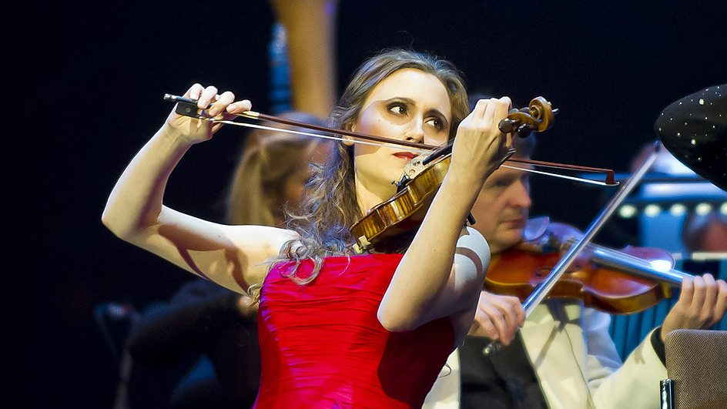ACTIVITIES.
I.LEE LAS SIGUIENTES ORACIONES Y ESCRIBELAS EN TU CUADERNO.
- Jennifer has played the violin since she was five.
- Jennifer`s father has been a music teacher for many years.
- They have lived in Cheshire for ten years.
- People all over the world have invited her to play in concerts.
ll. PUEDES IDENTIFICAR EL TIEMPO VERBAL DE ESTAS ORACIONES?
III. LEE LOS DIFERENTES CASOS EN LOS CUALES SE USA EL PRESENTE PERFECTO.ESCRIBELAS EN TU CUADERNO.

Unspecified Time Before Now
We use the Present Perfect to say that an action happened at an unspecified time before now. The exact time is not important. You CANNOT use the Present Perfect with specific time expressions such as: yesterday, one year ago, last week, when I was a child, when I lived in Japan, at that moment, that day, one day, etc. We CAN use the Present Perfect with unspecific expressions such as: ever, never, once, many times, several times, before, so far, already, yet, etc.
Examples:
- I have seen that movie twenty times.
- There have been many earthquakes in California

TOPIC 1 Experience
You can use the Present Perfect to describe your experience. It is like saying, "I have the experience of..." You can also use this tense to say that you have never had a certain experience. The Present Perfect is NOT used to describe a specific event.
Examples:
- I have been to France three times.
- Joan has studied two foreign languages.

TOPIC 2 Change Over Time
We often use the Present Perfect to talk about change that has happened over a period of time.
Examples:
- You have grown since the last time I saw you.
- The government has become more interested in arts education.

TOPIC 3 Accomplishments
We often use the Present Perfect to list the accomplishments of individuals and humanity. You cannot mention a specific time.
Examples:
- Man has walked on the Moon.
- Scientists have split the atom.

TOPIC 4 An Uncompleted Action You Are Expecting
We often use the Present Perfect to say that an action which we expected has not happened. Using the Present Perfect suggests that we are still waiting for the action to happen.
Examples:
- James has not finished his homework yet.
- The rain hasn't stopped

TOPIC 5 Multiple Actions at Different Times
We also use the Present Perfect to talk about several different actions which have occurred in the past at different times. Present Perfect suggests the process is not complete and more actions are possible.
Examples:
- The army has attacked that city five times.
- She has talked to several specialists about her problem, but nobody knows why she is sick.

IV. A QUE CASO SE REFIERE CADA UNA DE LAS SIGUIENTES ORACIONES?
  - Nobody has came to the party yet, but I´m sure everybody will come_________________
  - I have worked for this company for three years and I know all its processes._______________

  - Technology has changed our life, nothing is the same today.__________________

  - She has seen her husband with the same women many times but he doesn´t accept his fault._________________

V. DEBEN TERMINAR TODAS ACTIVIDADES PUES PASARÉ POR EL SALÓN HOY MISMO A RECOGER LOS CUADERNOS.Y NO HAY RECUPERACIÓN.

